**Manual**

This document provides information about how to deploy and test the program.

**Introduction**

This project aims to develop a distributed storage system over Google app engine services. For the project we have used JSP pages for front end design and Servlets to implement the required functionality.

The project contains three main files:

1. **index.html:** This is a link for the jsp file which actually defines the front end for the user. All the layout and tabs are definedunder this jsp file.
2. **web.xml:** This defines the servlet mapping of the jsp to the corresponding java class files.
3. **All java files:** It contains all the java executable codes of this project.
   * generatefile.java : Used to generate the files of different sizes.

**System Requirements**

* Eclipse IDE for Java Developers
* Java version 1.7.0_71 or above
* Appengine-Java-sdk1.9.15

**Program Execution steps on client System to deploy the Code:**

* In order to generate 411 different Dataset files run the given **generatefile.java** file and please make sure to edit the path in the line before running.

File file_Path = new File("\\required location for the files");

* To run the given project on Client Eclipse follow the below steps
  + goto File🡪 Import🡪 Select File system🡪 CSS53_GA
  + Now click on the imported project CSS53_GA🡪google🡪 deploy to App Engine.

To deploy the project in a new link, follow the below steps.

1. user must have google credentials (email-id and password)
2. Open chrome or Mozilla browser.
3. Goto google developer’s console (https://console.developers.google.com/project)
4. Create the Application in https://appengine.google.com/ and retrieve it’s

Application ID.

1. We created the application with Application id “progassign3”.
2. Enter the created application ID in file: appengine-web.xml which is find in the Path: “../war/WEB-INF/”
3. In the Eclipse, Deploy the code to Google App Engine by clicking google→ deploy to App Engine.
4. Once the code deployed go to the URL **<ApplicationID>.appspot.com** and validate the code.

Example - Our project Application Deployed URL is

[http://progassign3.appspot.com](%20http://progassign3.appspot.com)/

**Below are the Sample Screen Shots to Deploy Application on Client Side:**

Step 1: Import the package

Open Eclipse:

* File Import 🡪 Select File System 🡪 Browse for File🡪Select File 🡪 Click Ok

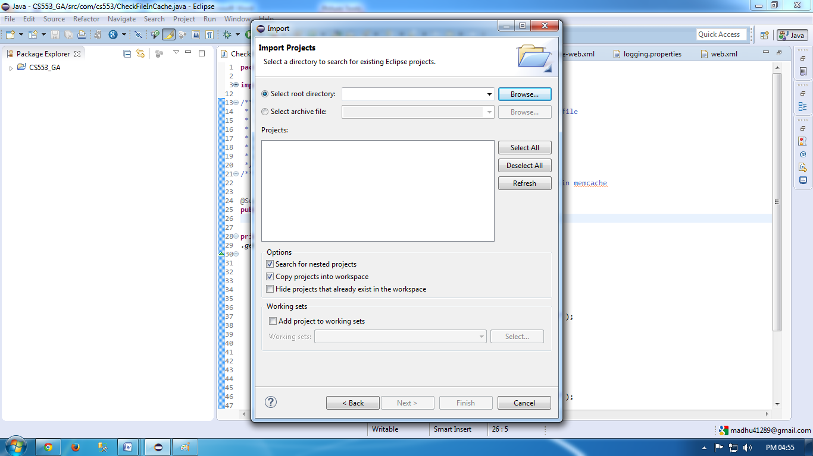

Step 2: To deploy on Link after you enter the created application ID in file: appengine-web.xml which is at “../war/WEB-INF/”

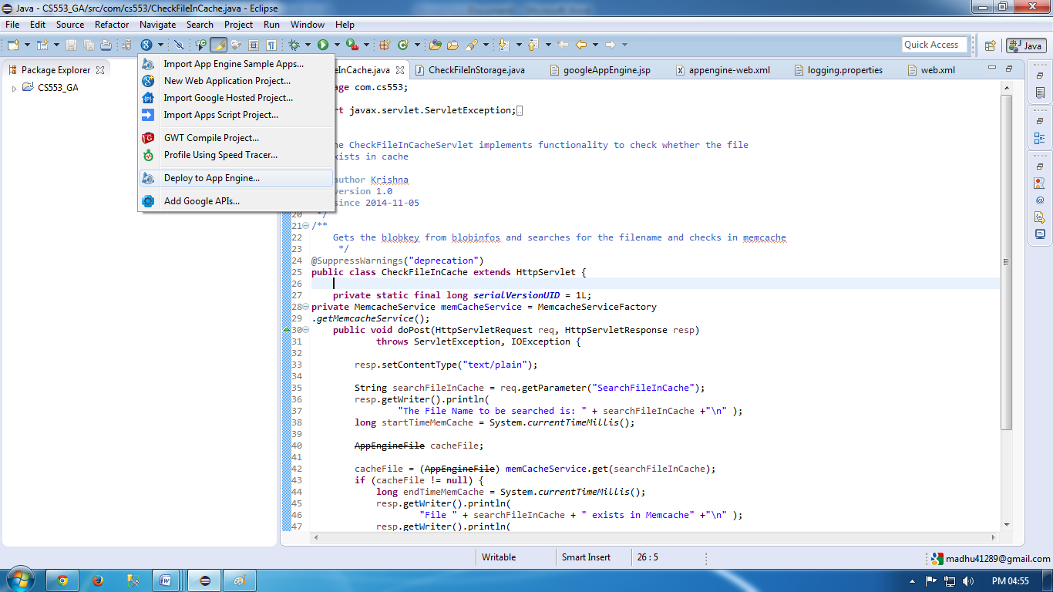

**Program Execution steps on Google App Engine Console link:**

Link url for our project:  [http://progassign3.appspot.com](%20http://progassign3.appspot.com)/

Screen Shot of Application Front end Page:

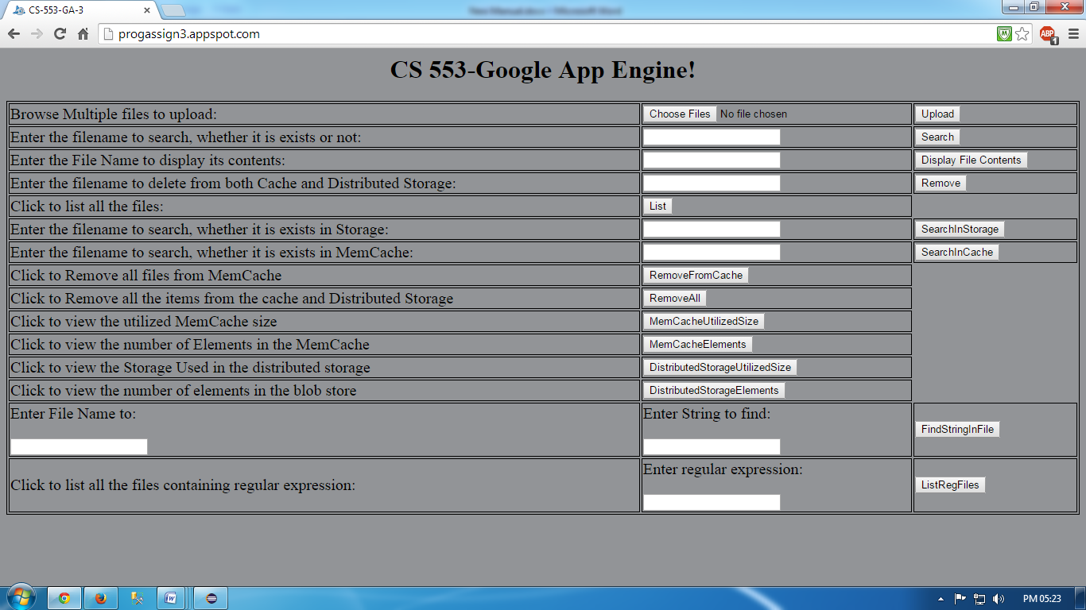

Please follow the below steps to implement all the functionalities of the program.

* Click on Choose Files button select the file list and then click Upload to upload the Files into bucket.
* If the files are more than 1Mb it will be stored only in Blob Viewer and all the files less than 1Mb we will stored both on Blob Viewer and MemCache.
* Click on Search button to search for a particular file name in Memcache or Blob Store.
* Enter the file name and Click on Display File Contents button to view the contents of the entered file.

* Enter the file name in box and click on Remove button to delete the file from both MemCache and Distributed Storage
* Click on List button to list all the files in Distributed Storage.

The Below functionality are implemented along with the main requirements

* Click “RemoveFromCache” button to remove all files from Cache.
* Click “RemoveAll” button to Remove all the items from the cache and Distributed Storage
* Click “MemCacheUtilizedSize” button to view the utilized MemCache size.
* Click “MemCacheElements” button to view the number of Elements in the MemCache.
* Click “distributedStorageUtilizedSize” button to view the Storage Used in the distributed storage.
* Click “DistributedStorageElements” button to view the number of elements in the blob store.
* Enter the File Name and String to find and then click on “FindStringinFile” button to view the contents of it.
* Click “ListRegFiles” button to list all the files

URL of the Site where Google App Project deployed is

http://progassign3.appspot.com/